Cloud Computing

**Name:** Jerusha Angel K

**Register No**: 727721EUCS049

Day-3

**Day 3_S3_CE1**

**Content Description:**

Create a S3 Bucket and create a folder in the bucket and upload a file in the folder.

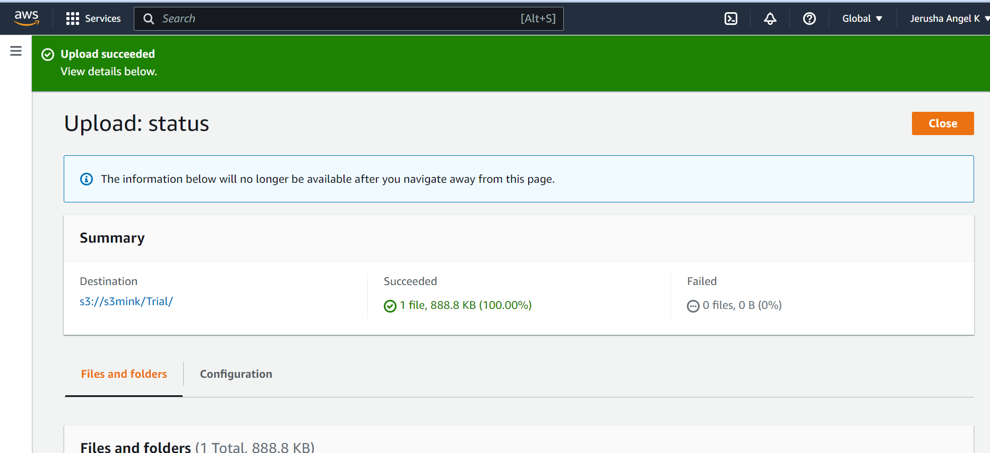

**Day 3_S3_CE2**

**Content Description:**

Disable "Block Public Access" for the bucket and enable public read access for a file.

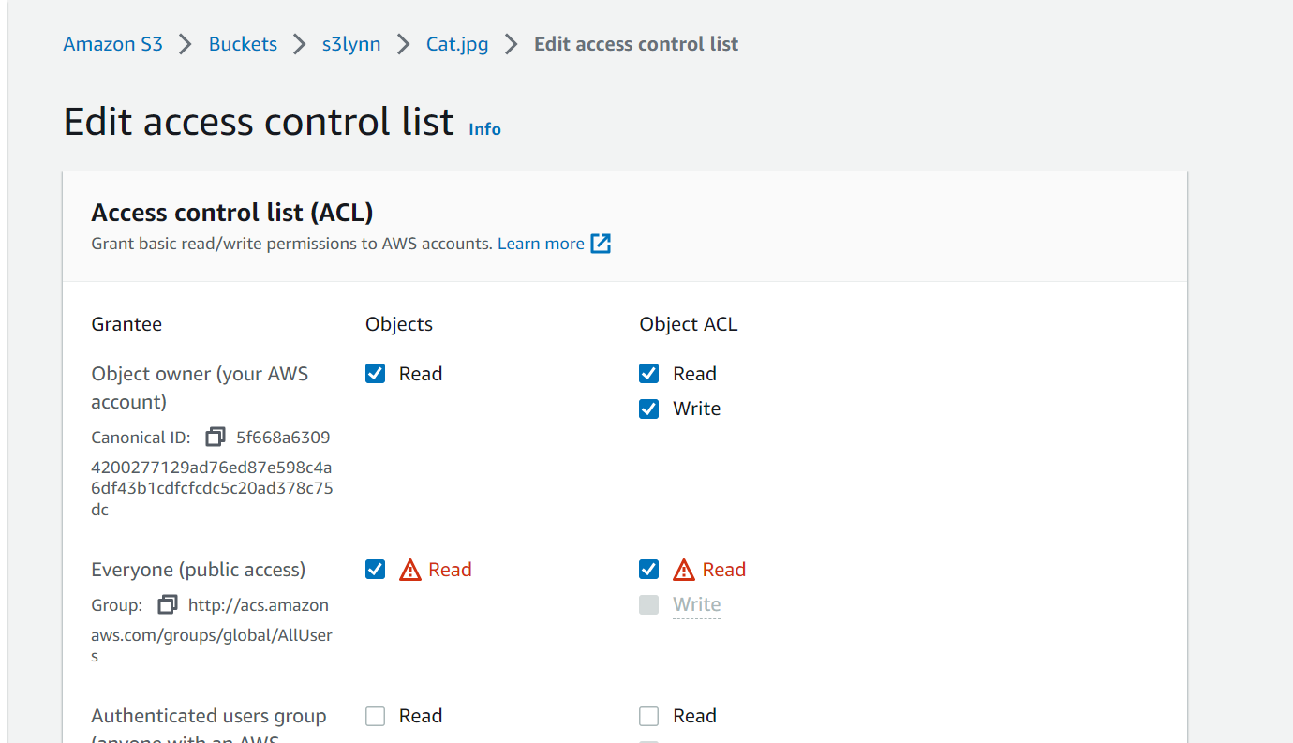

**Day 3_S3_CE3**

**Content Description:**

Create a bucket policy which should deny to read objects under a folder of a bucket.

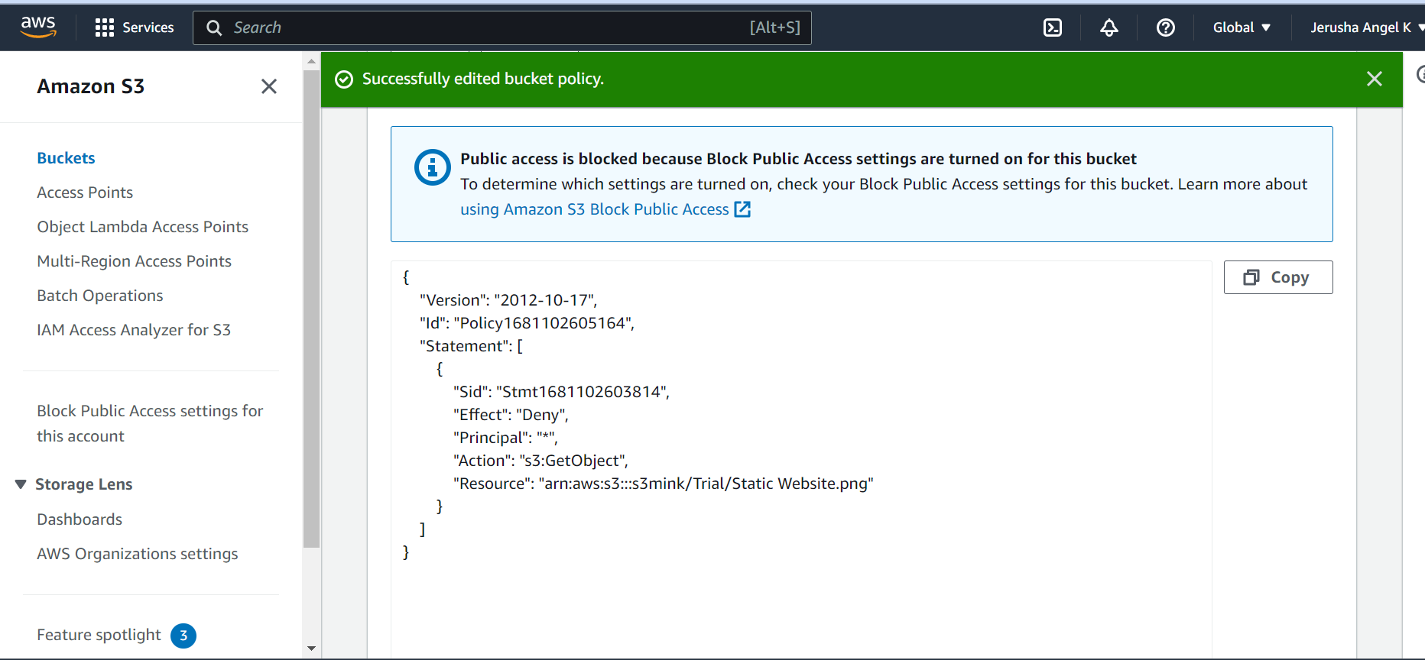

**Day 3_S3_CE4**

**Content Description:**

Enable versioning objects for a bucket and upload objects with multiple versions of it.

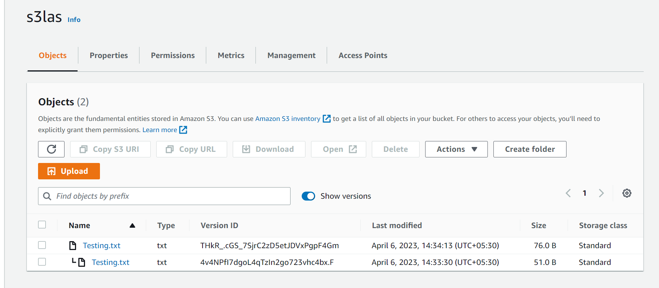

**Day 3_S3_CE5**

**Content Description:**

Host a static webpage in a bucket itself by using static website hosting feature of it.

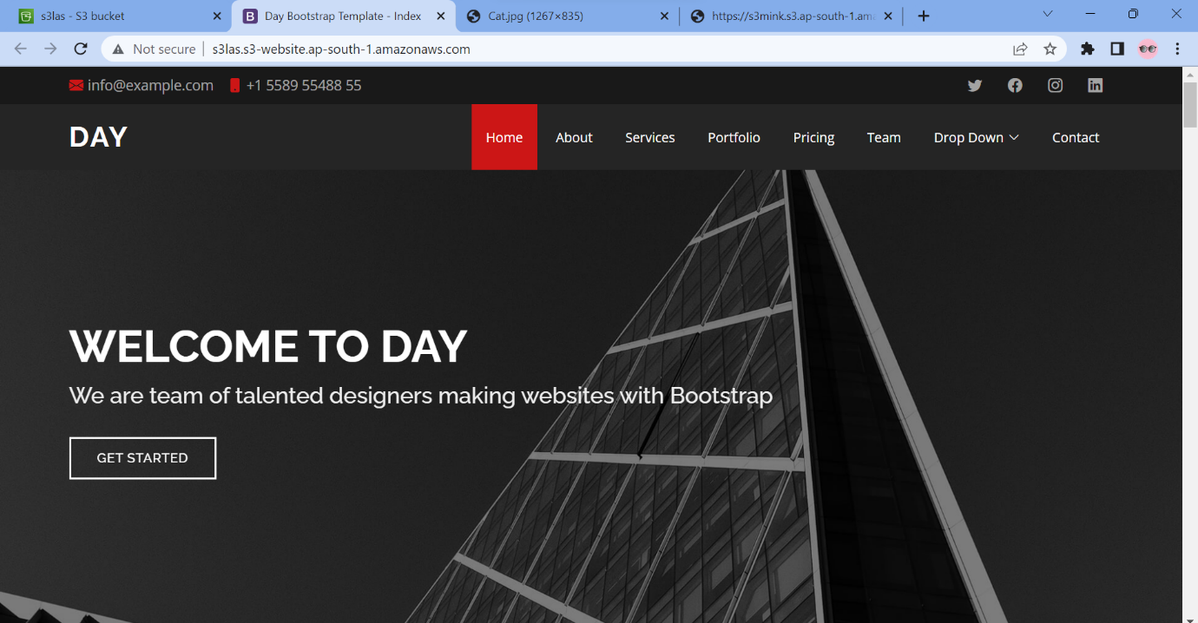

**Day 3_S3_CE6**

**Content Description:**

Enable a lifecycle management rule between various storage classes for a S3 bucket.

